Parish Christmas Tree
As you read this you will no doubt have taken down your own Christmas tree. However on the first of December the Parish Council planted a permanent Christmas tree next to the Pavilion on Back Lane.
The original plan was to install a new permanent Christmas tree on Greenbank and decorate it accordingly. As we reviewed the risks associated with this it became clear that the installation on such a slope would be difficult and also the future maintenance of it – a tree that may well double or even triple in size – could also prove challenging, given its proximity to the main road. We therefore had a bit of a rethink & opted for plan B, somewhere near the pavilion.
As you will see from the pictures, this meant carefully relocating the cricket scorers’ hut about 10 feet – an unforeseen consequence of our decision.
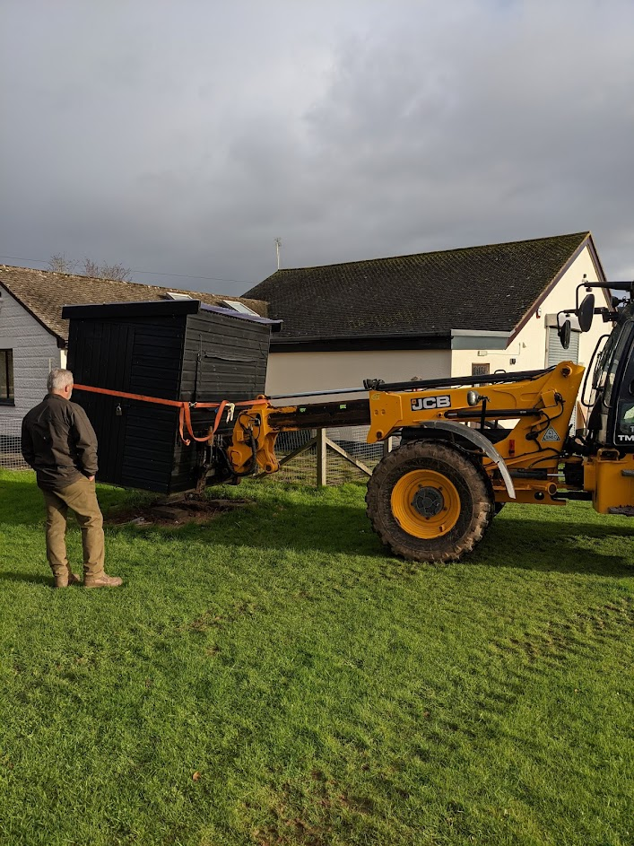
After that we dug a good size hole for the tree root to rest in.
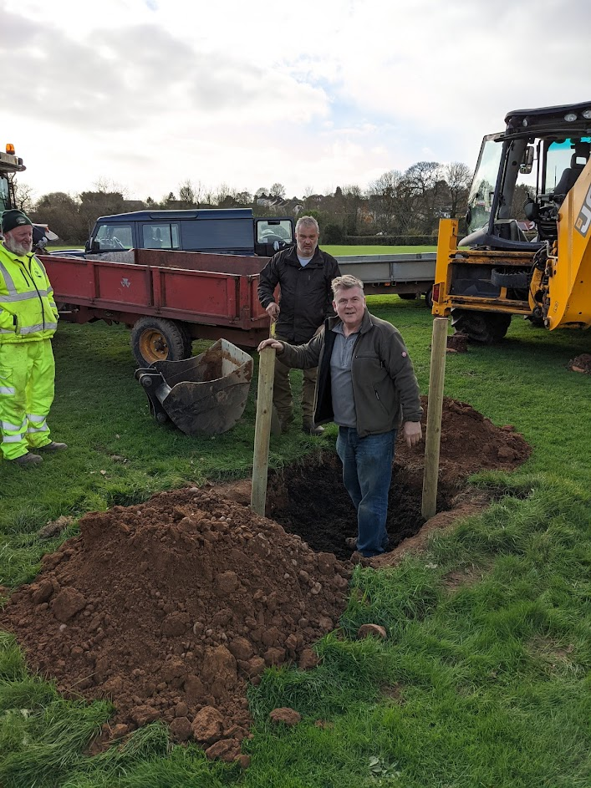
And made use of a JCB digger to help lift and lower the new tree, including the all – important root ball, into position
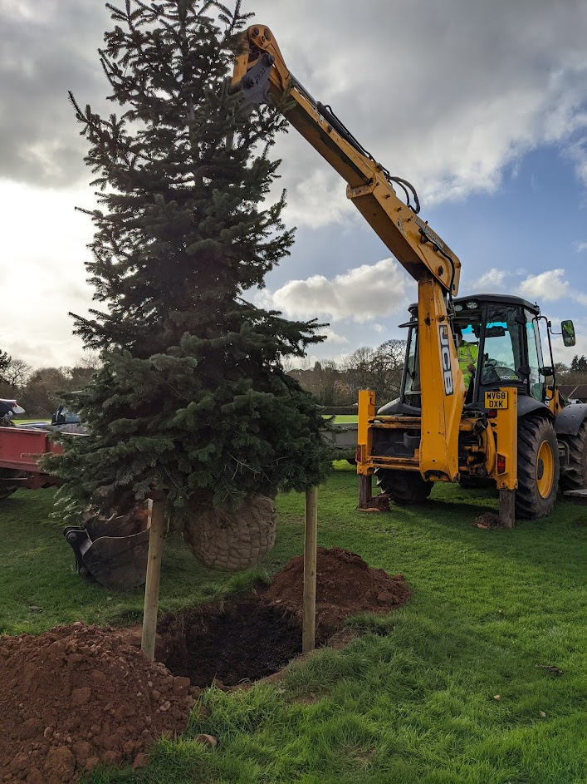
We watered it copiously, and then a couple of storms helped to do the same again. But thankfully, after all that, we ended up with a decorated Christmas tree!
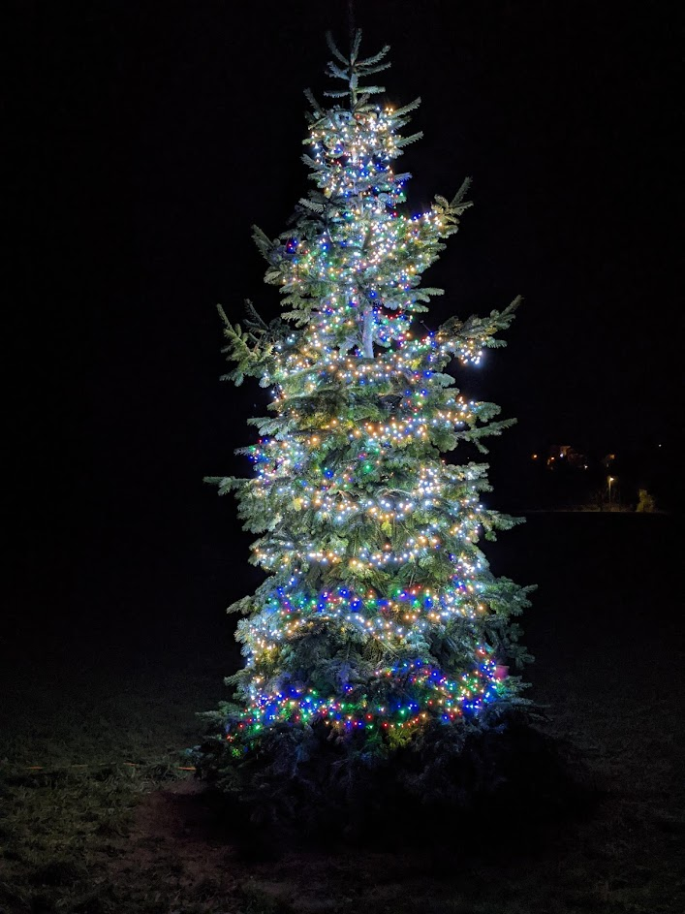
All being well we intend to leave the lights on the tree throughout the year.
At the time of writing the intention is to also try and decorate the existing large conifer on Greenbank with lights. You’ll know by now if this plan has been successful!
My thanks to all those involved; Howard of Bowhayes Farm Venn Ottery and Chris Drake (actually “old Mr Drake”) of Land Solutions Ltd, Venn Ottery Road, who helped us with the (literally) heavy lifting at short notice.

