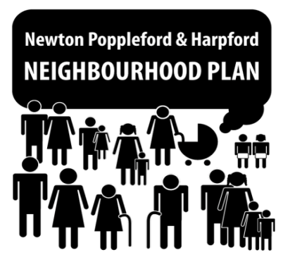

************************************************************************

CONSULTATION
on HOUSING STYLES

Come and have your say on future housing styles in the parish!

SATURDAY 9th SEPT 2017 – 2pm until 5pm
stall at Popstock on Sports Field

AND

SATURDAY 23rd SEPT 2017 – 11am until 2pm
at the Village Hall

