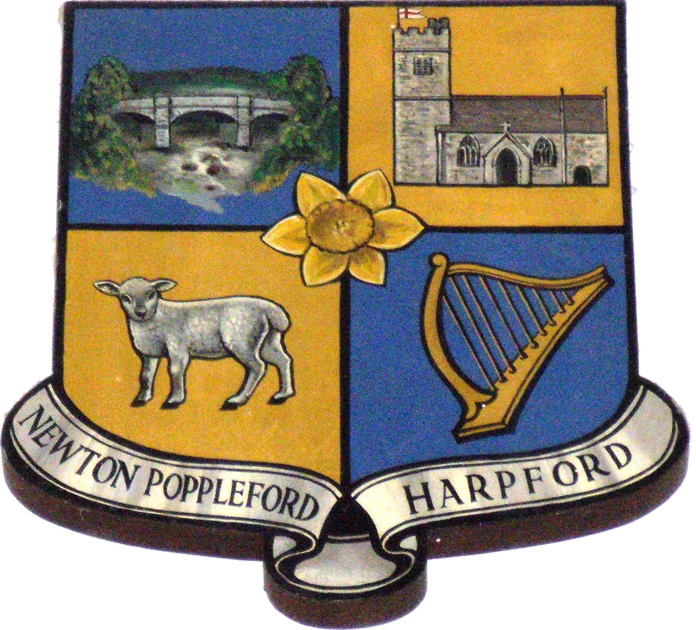

NEWTON POPPLEFORD AND HARPFORD PARISH COUNCIL
Chair: Cllr. H Jeffery, The Stables, Hoppins, Southerton, EX11 1SD
Proper Officer: Paul Hayward, Plumtree, Old North Street,
Axminster, EX13 5QF – 07711 929227
parishclerk@newtonpopplefordpc.co.uk

The Annual General Meeting of the Trustee Board of NEWTON POPPLEFORD PLAYING FIELD FOUNDATION (300848) – 18th January 2018 at 7pm at The Pavilion Building

Agenda

- Apologies for absence
- Chair’s report
- Secretary’s report
- Financial report for year ending 31/3/17
- Election of Officers: Chair, Secretary, Treasurer
- To arrange date for future AGM.
- Any other business to consider / Matters of Urgency
- Public Questions.

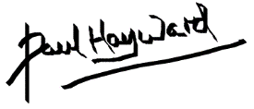 4th January 2018
Paul Hayward ( Secretary )
Newton Poppleford Playing Field Foundation, registered under the Charities Act 1993.

