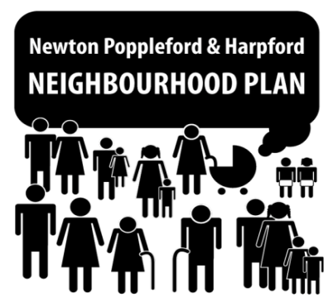
Newton Poppleford and Harpford Neighbourhood Plan
Meeting Agenda – 16th November, 2015, 8pm Cannon Inn, Newton Poppleford

- Welcome and Apologies

- Minutes of last meeting: Appendix 1
Action Points from previous meetings:
- Emma to meet with Gill to update the Project Plan
- Emma to draft a public engagement and consultation strategy
- Consolidate bullet points from the public consultations into one document for circulation to businesses (Emma)
- Employment and Services - Draw out key themes (Gill and others?)
- Format questions from all themes into one Word document: agreed that questions may have a yes/no/maybe format (Emma)
- Add photos of house styles to questionnaire (Emma and others?)

- Summary of Employment & Services theme public consultation comments

- Review of questionnaire items so far
  - Housing Theme
  - Health & Wellbeing Theme
  - Environment, Sport and Leisure Theme
  - Traffic & Transport Theme

- AOB and date of next meeting
  - Update on school involvement in the Neighbourhood Plan (Judy)
  - Plan of action for engaging with businesses and landowners (Val)
  - Agreement of date of next meeting (all)

Appendix 1: Minutes of meeting held on 9th November 2015

Newton Poppleford and Harpford Neighbourhood Plan
Meeting : 9th November 2015, 8pm Cannon Inn, Newton Poppleford
Present: Emma Taylor (Chairman), Gill Cameron-Webb, Val Ranger, Lorna Dalton,
Apologies: Anita Kemp, Marilyn Ashmead-Craig, Matt Coppell, Judy Cullip, Chris Ashmead Craig
- Minutes

Minutes of meeting previous meeting – carry over to next week’s meeting

- Purpose of meeting

Arrangements for the Funday on Sunday 27th September had taken precedence in the previous couple of meetings so this informal meeting was called to recap and discuss action points to progress the Neighbourhood Plan.

Action Points:

- Consolidate bullet points from the public consultations into one document for circulation to businesses
- Employment and Services - Draw out key themes
- Format questions from all themes into one Word document
- Add photos of house styles to questionnaires
- Questions to have Yes/No/Maybe options

For later consultation - Landowners/Farmers, SHLAA

Date of next full meeting: Monday 16th November 2015 @ 8.00 PM, The Cannon

