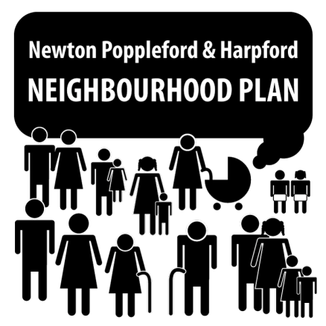
Newton Poppleford and Harpford Neighbourhood Plan: Update to Parish Council meeting, 23rd February 2015

The Neighbourhood Plan Steering Group met on 16th February. At this meeting, Terms of Reference were agreed for the group. These will be uploaded to the area on the Parish Council website (http://www.newtonpopplefordpc.co.uk) that is dedicated to the Neighbourhood Plan.
At the meeting, membership of the five working groups (employment & services, environment sport & leisure, health & wellbeing, housing, traffic & transport) was also established. There is still capacity for others to join these groups. Using the comments from the recent public consultation, along with the raw data from the Parish Plan questionnaire, each working group has been tasked with identifying common themes that arise from the comments. These themes will inform subsequent discussions and surveys sent to the public during the course of the plan-making process.
Members of the Steering Group (Chairman, Vice-chairman, Secretary) will meet this week with Catalyst (Devon Communities Together), who have experience of guiding communities through the Neighbourhood Plan process. We will seek advice on the key steps to take, in order to maximise public involvement in generating the plan and ensure a truly representative document.
The next meeting of the Steering Group will be on 24th March (8pm, Skittle Alley, The Cannon), where working groups will report back their findings and establish the key issues and questions that need to be addressed. All members of the public are cordially invited to join us to have their say.
If you are interested in becoming a member of one or more working groups, or even just contributing your views on a single occasion, please email the Steering Group on NPH-NPlan@outlook.com or 01395 567457, contact a Parish Councillor or simply turn up to one of our meetings, where you will be made very welcome.

