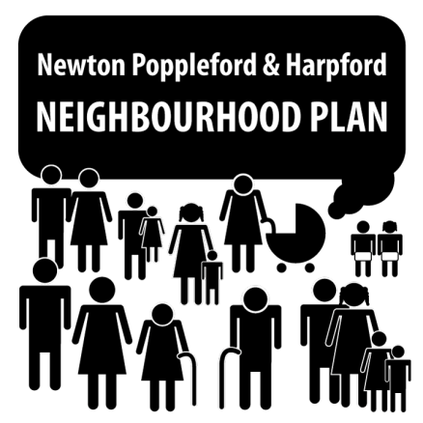
Newton Poppleford and Harpford Neighbourhood Plan: Update to Parish Council meeting, 29th June 2015

The Neighbourhood Plan Steering Group has run its own community consultation events, and also attended some events organised by other groups. We have used comments from the public to gain insight into how the community feels about the local area, within five ‘themes’. The comments received can be seen on the Neighbourhood Plan area of the Parish Council website (http://www.newtonpopplefordpc.co.uk).
The Steering Group is now at the point of drawing up a further questionnaire that will be delivered to every household in the plan area. Key issues will be drawn out from the comments received, and questionnaire items will be written to explore these issues - and possible solutions - in more depth.
Members of the Steering Group will be in the playing field area on Thursday 30th July (4-8pm) when the Art Society is holding its annual exhibition and the tennis club/cricket club challenge match is taking place. We will use this opportunity to run our interpretation of the community consultation comments (and some of our draft questionnaire items) past members of the public for comment.
We are also hoping to organise a Community Day, most likely in mid-September, subject to availability of the Pavilion. This day is intended as a showcase for local businesses, community groups, sports clubs etc.. It will help the Neighbourhood Plan group to better understand the composition of our community, as well as offering an opportunity for these groups to raise awareness of services and activities offered within the parish. At this event, we hope to gain further feedback on our summary of each of the five themes and our proposed questionnaire. We hope to be able to sell food, drink and goods, and offer demonstrations or opportunities to try activities at the Community Day, and in future years we hope that this may become an annual parish fete. Any offers of help in organising this event would be greatly appreciated.
The next meeting of the Steering Group will be on 2nd July (8pm, Pavilion), where issues relating to the “Housing” and “Environment, Sport & Leisure” themes of the plan will be discussed. All members of the public are cordially invited to join us to have their say.
If you are interested in becoming a member of the Steering Group, or even just contributing your views, expertise or a willing pair of hands on a single occasion, please email the Steering Group on NPH-NPlan@outlook.com or 01395 567457, contact a Parish Councillor or simply turn up to one of our meetings, where you will be made very welcome.

