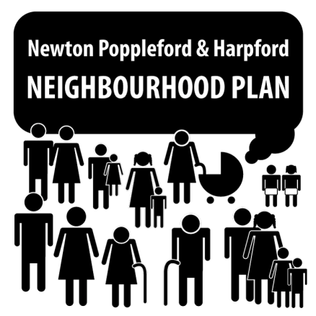
Newton Poppleford and Harpford Neighbourhood Plan: Update to Parish Council meeting, 27th July 2015

The Neighbourhood Plan Steering Group is currently drafting items for a questionnaire to be delivered to every household in the plan area. Key issues are being drawn out from the community consultation comments received, and questionnaire items aim to explore these issues - and possible solutions - in more depth.
Members of the Steering Group will be in the playing field area on Thursday 30th July (4-8pm) when the Art Society is holding its annual exhibition and the tennis club/cricket club challenge match is taking place. We will use this opportunity to run our interpretation of the community consultation comments (and some of our draft questionnaire items) past members of the public for comment.
A date has now been set for our Community Day/Fete, which will be held on Sunday 27th September, starting at 11am and continuing until late evening. This day is intended as a showcase for our community, and we hope to have a number of stalls, demonstrations and fun activities for all the family, along with food and drink. It will help the Neighbourhood Plan group to better understand the composition of our community, as well as offering an opportunity for these groups to raise awareness of services and activities offered within the parish. We now invite local businesses, community groups and sports clubs who would like to take a stall to get in touch. In particular, we are seeking local musicians, groups and/or mobile DJs, of a variety of musical styles, who would like to volunteer to play a short set at the event. Any offers of help in organising this event would be greatly appreciated.
The next meeting of the Steering Group will be on 4th August (8pm, Cannon Inn). All members of the public are cordially invited to join us to have their say.
If you are interested in becoming a member of the Steering Group, or even just contributing your views, expertise or a willing pair of hands on a single occasion, please email the Steering Group on NPH-NPlan@outlook.com or 01395 567457, contact a Parish Councillor or simply turn up to one of our meetings, where you will be made very welcome.

