RSPB Aylesbeare Common Reserve
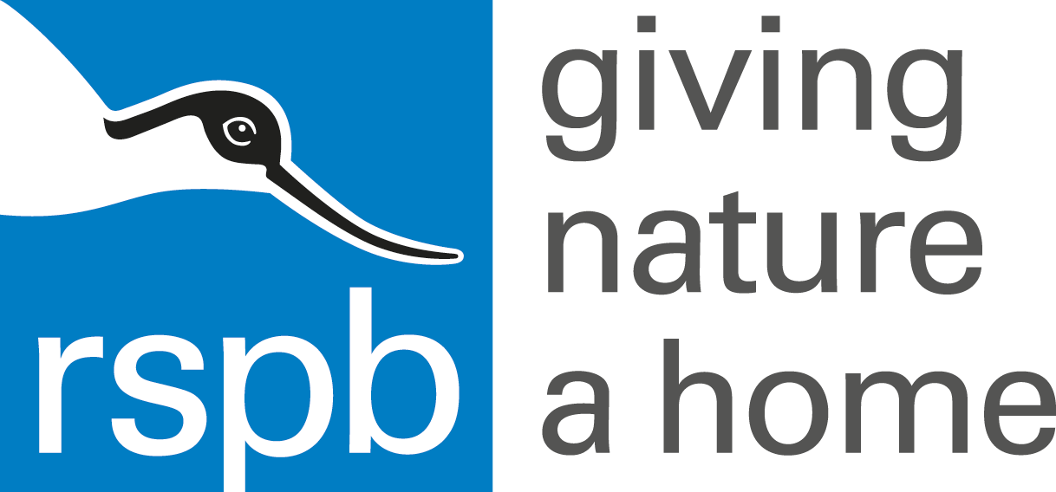

August 2015 newsletter

The great British summer rolls out into a humid, wet, blustery August. We can’t cut our hay at present because of the rain but, on the upside, at least the heaths are less susceptible to wild fires.
Plenty of butterflies to see around the reserve: it seems to have been a good year for fritillaries – silver-wash and dark green have been seen very frequently. The silver-studded blues are still hanging on, though not in the sort of numbers that could be described as a colony.
Southern damselflies have had an exceptional year, nearly 200 picked up on one count! And there are plenty of other dragonflies to see hawking over the ponds.
Although the cross-leaved heath and bell heather are beginning to wane, the ling is still flowering well, giving that lovely purple wash to the hill sides.
But where are all the birds? I hate this time of the year because it goes so quiet – breeding is over, so the dawn-chorus by vigorous territory defenders has dried up and the adult birds who have been working so hard to raise the next generation are taking time out to moult. Because this means they can’t fly very well they tend to skulk about in dense vegetation and not draw attention to themselves. Apart from the blackbirds who ate all my gooseberries – I’m watching you!
We have been spending a lot of time surveying: our volunteers have been continuing the heather survey on Withycombe Raleigh Common – documenting the age and structure of the heather to help us plan our future management. Following the National Vegetation Classification re-survey of the main reserve a couple of years ago, carried out by our favourite consultant, staff and volunteers have been getting to grips with the system ourselves to document the habitats on Venn Ottery Common – I have never had so many ticks to remove as when we worked in the mires and bogs at the bottom of the hill!
Another piece of survey work just coming to an end is looking at nightjars on areas which have been recently cleared of trees. We got permission from Clinton Devon Estates to send volunteers out to look and listen for nightjars where plantations had been felled over the last few years. We are interested to find out if these new habitats are being colonised and how long it takes. This is the second year of the survey, so many thanks to the volunteers giving up their evenings to trek out into the wilds and listen for goatsuckers!
Lots of cows are out on the heath grazing, though not quite as many as we would like. Our Dartmoor and Exmoor pony empire has expanded to include Trinity Hill nature reserve: being grazed for the first time for 40 years! We are also supplying ponies to the Stockland Turbaries to keep those fascinating habitats in good condition.
Closer to home, we have now received planning permission for our new office and volunteer accommodation building, which will go up next to our existing workbase. So we are going to have the builders in for the next few months, but I am really looking forward to being able to move into our new log cabin.

