Contents
Police Traffic Speed-watch 1
VAS camera 1
Four Elms Hill 1
Vandalism and attempted burglary 2
Police advise dialing 999 if you suspect a crime is being committed 2
Dog out of control 2
Car Parking 2
Bird Scarers/Bangers 2
Japanese Knotweed 2
Harpford Woods 3
Dog mess 3
Neighbourhood Plan 3
King Alfred Way Planning application 3
EDDC new Council 4
Register of interests 4
Scrutiny Committee 5

Police Traffic Speed-watch

Residents will be aware that the police were monitoring traffic last Thursday 20th June and I believe had a very successful day catching motorists who were in breach of breaking the speed limit, driving without tax, MOT and insurance, driving under the influence of drugs etc. We hope to hear more from our local police on this at the parish council meeting on Monday 24th June 2019.

VAS camera

Residents that live at Burrow have reported to me their concerns over traffic speeding at that end of the village. They feel that this end of the village (the western end) needs a VAS camera post too owing to the traffic speed, lack of pavements, how terrifying it is waiting for a bus or walk to the bus stop on a road where the traffic speeds right next to them with no protection at all. Another resident has asked why we do not have more VAS cameras in the village rather than moving the same camera around the village. I suggested it might be to do with cost. The resident suggested that residents may be willing to contribute financially to more cameras in the village, something the parish council may wish to consider?

Four Elms Hill

The traffic survey done by Jacobs is due to come to the HATOC (Highways and traffic orders committee) in July. Hopefully their report will support the request for double white lines and a lowering of the speed limit into the village. At that point a VAS camera at the top and bottom of the hill would be beneficial. That meeting will have taken place by the time of my report next month.

Vandalism and attempted burglary

Friday night/Saturday morning 21/22 June 2019. I am grateful to residents for letting me know about the rampage that took place in the village in the early hours of Friday night/Saturday morning including vandalism to cars, dumping the newspapers from the newsagents into the brook, destroying books from the telephone kiosk. Perhaps, worst of all, was the attempted burglary of a 90 year old residents home leaving them shaken, shocked and feeling vulnerable. I understand the police were very responsive. I am hopeful they will catch the culprits and that some restorative justice takes place.

Police advise dialing 999 if you suspect a crime is being committed.

At the parish council meeting on Monday 24th June, the police attending emphasized that if you suspect that a crime is being committed, dial 999 and ask for police to attend without hesitation rather than waiting and using the non-emergency 101 number at a later date. The sooner you report a crime via 999 the more likely it is that the culprits will be caught.

Dog out of control

It has been reported to both the police and to EDDC that there is a dog who runs out of his garden in Back Lane, Newton Poppleford (near to the pavilion) and behaves aggressively towards people and other dogs. It was clarified to me by the police and EDDC that if a dog attacks another dog, that is a matter that Environmental Health at EDDC would follow up, but if a dog attacks or bites a person, that is a police matter. There is a police report with a crime number of a dog to dog incident.

EDDC no longer have a full time dog warden but the duties of the dog warden have been picked up by other environmental health staff. This does not include the collection of stray dogs which fortunately is rare in our area.

If anyone has any concerns about dog behaviour in the area but is reluctant to report this, do let me know.

Car Parking

Thank you to those who have contacted me with complaints about parking in the village;. Thanks to those who have sent me photos of cars parked illegally, these are very helpful in identifying those responsible and I have passed them onto the police.

Bird Scarers/Bangers

A number of residents have reported concerns about the exceptionally loud bird scarer being used by a business at the far end of the village. The noise is so loud it does not sound like a bird scarer, but more like a bomb. Residents are being disturbed as early as 5.00 am. I have raised the matter with Environmental Health. Please contact me if you have experienced such a disturbance.

Japanese Knotweed

I have received reports of this growing on the highway in the area. I have reported this as it is very important that is it treated by experts as even tiny amounts are capable of regenerating and it can be spread also by the tiniest amount. JK on private land must be addressed by landowners. It is extremely invasive and very damaging if growing near to houses.
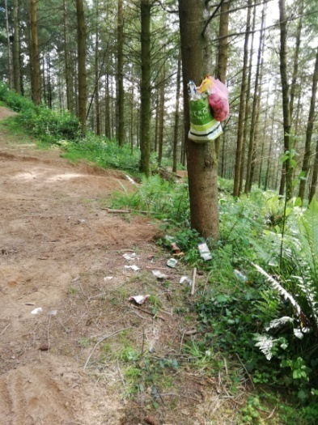
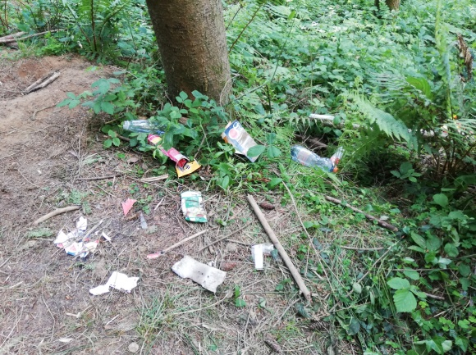

Harpford Woods

Cyclists have long used Harpford Woods for off road cycling practise and I am happy to see residents enjoying our environment, they usually are very respectful of other users. However, I was shocked to see the litter left there recently during half term. A friend and I recently filled two black bin liners with loads of empty single use plastic bottles, crisps and sweet wrappers, a can of mega butane gas, on just one outing. This is shocking on so many levels.

Dog mess

Did you know our general waste from litter bins goes to an incinerator and is burnt for energy? However waste from dog bins cannot be treated in this way. 20 tonnes of dog waste a MONTH goes to landfill! Thanks to my fellow councillor Denise Bickely of Sidmouth Plastic Warriors for this information. It is better for the environment if, instead of specific dog waste bins, we had general bins in their place (you can put bagged dog waste in these) with a recycling bin alongside. This is what the parish council did in Venn Ottery recently when a new dog bin was requested. It is something the parish council may want to think about in the coming years.

Neighbourhood Plan

This is now at the pre-submission stage. It has been sent to EDDC for informal feedback and that has now been received. We have had the expected feedback about not making ‘hard and fast rules’. ‘Development will not be permitted where’… would have to be changed to ‘development will not usually be permitted where’ … In other words no ‘anti-development’ statements can be made. We do not have to accept all the suggested changes but it is likely that an inspector would also throw out statements at a later date that put an undue burden on developers in these times where the government wants to see more houses being built not matter what cost to the environment or communities.

King Alfred Way Planning application

CDE put in their application for two luxury houses instead of a doctors surgery and this went to EDDC’s Development Management Committee (DMC) for discussion on 11th June 2019. EDDC Planning officers had recommended approval of the two luxury houses without any contribution for affordable housing being required. DMC now has a completely different makeup in the new administration. I was unable to attend and so emailed in advance to give the new DMC councillors some background and to give my view on behalf of residents. My view was that all interested parties should get around one table with a view to seeing if there was any way forward for the surgery. Interested parties would comprise: CDE, Coleridge Medical Centre, the parish council, me, a representative from the local Clinical Commissioning Group, potentially any other medical centres or support services that might be interested in offering a service at a medical venue and so on.

I had been told emphatically by CDE prior to the DMC meeting that if permission was given to build two luxury houses, at that point CDE would be willing to discuss the possibility of building residents a doctors surgery instead. Some people might be sceptical about that. CDE told me if DMC refused them permission for the two luxury houses, CDE would go to appeal. CDE expected the appeal to take 6-8 months and that they would win that appeal with costs.

The CDE approach seems completely back to front to me, and not very sensible from a business point of view. A meeting around the table in the near future would help to clarify whether all possible options for the surgery had been put forward. It may be we then have to agree that a new surgery is simply not possible but until the talks take place how can we possibly know that?

At the DMC meeting resident Gill Cameron-Webb spoke eloquently about broken promises and the medical needs of the village; Parish Council Chairman Chris Burhop also impressed DMC with his argument that not all options for the surgery had been fully explored. I had emailed DMC members to remind them of the words sent to me by CDE on 12th August 2015:

“As you know we (CDE) are not like a traditional developer who tries to squeeze the last penny out of any development. We wish to leave a legacy”.

My view was that they still can.

DMC members agreed that not all options had been explored and voted for a further 3 month delay in making a decision on the application for two more luxury houses. The immediate response from CDE was that they were putting in an appeal to the planning inspector, that all talks re a new surgery were off, that they were not required to provide a surgery and no one could make them. They stated that by the time the appeal is heard, Cavanna would have left site and it would cost them more to develop any further buildings and this therefore would further damage any chance of a surgery being built.

I wrote to CDE explaining that if round the table talks were held immediately, it could well prove true that a new surgery is not viable and at that point there could be no further objection to them building whatever they choose on site and that this might be quickly approved without even going back to DMC.

But no, CDE are determined to take the litigious route even though that makes no business sense. Residents will also be aware that CDE winning a legal case does not mean that justice has been done.

EDDC new Council

At Full Council on 22nd May 2019 most committee posts were agreed. The new Leader of the Council is Independent Cllr Ben Ingham and his Deputy is Susie Bond, also an Independent Councillor. Conservative Stuart Hughes was elected as Chairman and I was elected as Vice Chairman. There are many changes within committee make up this time around. It will take some time for everyone to settle into their new roles but hopefully we will see some positive changes.

Register of interests

I have declared my personal interests in Harpford Hall, my membership of the Campaign to Protect Rural England (CPRE Devon), and my new membership of the Otter Valley Association (OVA). All of these are non-political organisations. The latter two organisations work tirelessly behind the scenes to protect and promote our unique local environment , always responding to government consultations which might impact this and responding to local issues that affect residents. I was amazed to find that the annual fee for being a member of the Otter Valley Association is just £5 per year and I am sure that as a very small charity they would appreciate other local people joining them to help them to fight our corner.

Scrutiny Committee

There was a lengthy debate about the new ipads that all councillors are now expected to use to do their EDDC work – how had we arrived at the situation where councillors felt hampered by these new devices which are almost universally detested. I asked how much they had cost? Answer - £48,000. I asked how they were insured. Answer – they hadn’t got around to finding that out. I was then emailed after the meeting to say they were ‘self-insured’. I questioned whether this meant the ipads insured themselves (how very intuitive) or if I was expected to insure it myself? No answer to date.

Councillors can now only access their EDDC emails via the ipads. I cannot imagine what is so secret at EDDC that security needs are higher than considered necessary for the NHS and numerous other public sector services

I am not prepared to carry around the ipad which weighs over 1kg and measures 11” x 8.5” and fits neither in my pocket nor handbag so I am now limited to checking my EDDC emails before 7.30 am and leaving for work or after a working day and eating etc. It is often around 9.00 pm before I check them again. This is making the days very long indeed and frankly not very productive.

Val Ranger
Ward Councillor, Newton Poppleford and Harpford. Tel 07475201340 vranger@btinternet.com

