Contents
Governance System at EDDC 1
King Alfred Way – DMC 6th August 1
Four Elms Hill 2
Parking, restrictions and drainage in Newton Poppleford 2
Neighbourhood Plan 3
Crowd Funding and Community Building Fund 3
Computer Scam 4

Governance System at EDDC

As a follow up to my explanation last month of different possible governance arrangements, it was resolved at the Cabinet meeting on 10th July that the Overview Committee should look into whether EDDC should change from the Cabinet System to the Committee system or a hybrid system taking the best of each. This would also involve looking at other councils who have made the change from the Cabinet system to try to determine which system would work best for EDDC.

This is something that I had hoped would be looked into during the last administration but of course there was no incentive for the then ruling party to look to share decision making, preferring to present councillors with a ‘fait accomplis’ which was then voted through by the then majority party. I will keep you posted on the outcome.

King Alfred Way – DMC 6th August

You may recall that in the July Development Management Committee meeting, councillors voted for a 3-month deferral on the decision to allow CDE to build 2 luxury houses instead of the doctor’s surgery, asking CDE to engage with a round of talks with all stakeholders. Instead CDE refused to talk to the parish council or me and went straight to appeal for non-determination. In a bizarre turn of events the application appeared again on the EDDC DMC schedule on 6th August, a month short of the 3 months delay requested. Furthermore, a press release was issued the Friday before the meeting, which appeared effectively to pre-determine the decision. When queried about the application being back on the agenda and the timing and contents of the press release, EDDC officers stated that the decision on the application was no longer in the hands of the DMC/EDDC but was on the agenda to determine what the decision WOULD have been had the decision been down to DMC. Also, DMC members needed to decide if EDDC should fight the appeal and if so, on what grounds. This appeared to make no sense at all to anyone but EDDC officers and a few councillors.
I attended the DMC meeting. Chris Burhop explained that prior to the meeting the parish council had put forward a proposal to CDE to take on the lease of the surgery to give CDE the business security they needed. After some DMC debate a proposal was put forward to refuse the application on the grounds of lack of community benefit, this had much support around the room. This was knocked back after heavy steering from EDDC legal officers. The vote to support the application went through with 7 councillors supporting approval of the application, 5 voting against and 2 abstentions. This meant ultimately that DMC /EDDC would not to ‘fight’ the appeal. My own view was that I hoped that in future DMC members should never again be swayed again by promises of ‘community benefit’ unless that could be secured by legal agreement. Even now CDE could easily build a new surgery but they choose not to. Furthermore, the Housing Strategy Officer recommended that if permission were given for the two additional houses, they clearly formed part of the 42 houses estate and CDE should also provide one additional affordable home (AH) on site to comply with EDDC housing policy on ratios. Senior planning officers disregarded the advice of their own housing strategy officer and recommended NO additional AH contribution. CDE have not come out of this saga well at all and the following comments were made at the meeting. Councillor Mike Howe, Chairman of the Development Management Committee, told the meeting CDE had acted 'atrociously' and could not be considered an 'ethical or nice developer'.
Cllr Olly Davey said, unless 'legally enforceable', 'any promise that a developer makes is not worth the paper it is written on'.
Councillor Paul Arnott said the application was the most 'spectacular orbit of deceit and betrayal' and the council should mount a challenge despite the costs. He said: "It's so mired in lies and deceit going back years, betrayal, treachery, accusations of wording.
I could not agree more with the above sentiments. Quite by coincidence I met a new resident of the new houses today who spoke of his frustration with the lack of the doctor’s surgery that had been promised. He also pointed out the irony that school children are considered to be out of catchment for Kings School, Ottery and yet the child was supposed to attend Coleridge Medical Centre in Ottery in order to see a doctor. So new residents are as frustrated with the process as the rest of us. What a mess.

Four Elms Hill
The Highways and Traffic Orders Committee on 18th July 2019 supported to support proposals to reduce the speed limit to 40 MPH at the top of the hill (subject to consultation with Devon and Cornwall police) and to have double white lines for the length of the hill. Thanks again to Chris Burhop from the Parish Council and Sergeant Andy Squires for speaking too again. The minutes also state:
(d) that consideration be given to the re-painting of road markings; the use of high friction surface and edge marking at the location set out in (a) above
I am very relieved with this outcome. I attach here a photo of two large lorries passing on the hill.
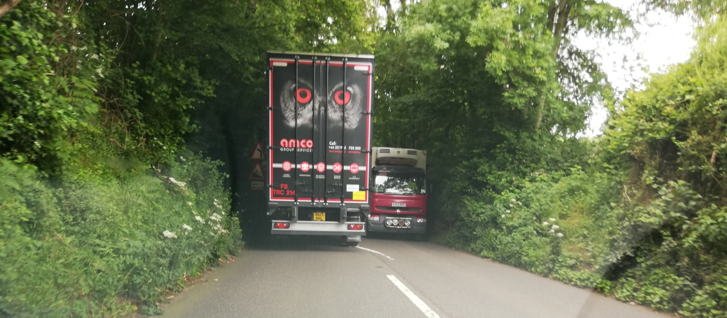

Parking, restrictions and drainage in Newton Poppleford

A meeting was held with Highways Officer Mike Brown, Parish Council Chairman Chris Burhop, DCC Councillor Claire Wright and myself to look at the provision of more double yellow lines at ALL junctions that meet with the main A3052, and to improve safety around the school using yellow lines and zigzag markings. The meeting was very positive and the Highways officer very helpful, though nothings at DCC level happens very quickly. A resident had also raised concerns with me about the flood alleviation channel which runs under the A3052 near to Otter Reach which is chocked up with foliage and small trees etc. The Highways Officer confirmed that the channel is the Environment Agency’s responsibility. Finding someone at the EA who agrees with this has been more than deeply frustrating but I will continue to pursue this.

Historically we raised the issue of lack of parking in the King Alfred Way planning application right back to 2013. These concerns were dismissed by EDDC and Highways but already residents are parking on the pavements and raises the question of whether the pavement width complies with policy.

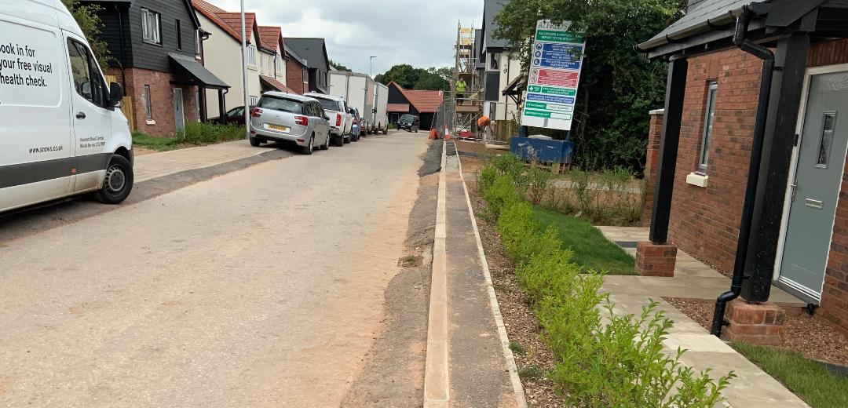

Neighbourhood Plan

This has been to EDDC Neighbourhood Planning Officers for their informal view and they have come back to us with their initial comments and advice. Officers have been really helpful and engaged in helping us to do the best for our parish; they have spent hours of time with us. Just recently we have been trying to determine the especially treasured ‘countryside views’ that residents would most like protected as they can be mapped as part of our plan. If any reader has a favourite view, send it to me as soon as possible so we can try to include this. The plan should be ready to be formally submitted to EDDC for consultation shortly. From there it goes to the planning inspector for their view and probably further changes before being ready for public consultation.

Crowd Funding and Community Building Fund

There is still over £95,000 for funding available to East Devon’s community and voluntary groups through Crowdfunding from EDDC in partnership with DCC and Devon and Cornwall Police. EDDC are running a free ‘introduction to Crowd funding session in Honiton on Monday 2nd September 2019 from 4.00 – 5.30 pm. You must book a place in advance via email crowdfund@eastdevon.gov.uk. This is a separate fund from the Community Building Fund also run by EDDC. More information about the differences between these two funds and the criteria for each can be found on the EDDC website.

Computer Scam Warning

I thought I was immune to computer scams etc, never taking unsolicited calls, but I made the mistake of phoning an 0800 telephone number for what I believed to be Hewlett Packard Support last week when I had a problem in the evening with my printer. It was a scam number. Thankfully our own local Al Findlay.com sorted me out (I didn’t contact him in the first place as it was the evening) and he reminded me to always do a ‘reverse lookup’ when you find a telephone number through Google. He Googled the telephone number I had used and said about 30 warning messages came up immediately. Consequently, I did a ‘reverse lookup’ when searching for the name of a specialist in animal law, and was saved from contacting someone I had intended to take advice from who had a proven record of being untrustworthy. Life is very complicated sometimes!

Val Ranger
Ward Cllr Newton Poppleford and Harpford
Vranger@btinternet.com, Tel 07475 201 340

